Lab 10:
Q.1. A machine tool in a manufacturing shop is turning out parts at the rate of every 5 minutes. When they are finished, the parts are sent to an inspector, who takes 4±3 minutes to examine each one and rejects 15% of the parts. Write a GPSS program to simulate using the concept of storage. (Here storage has 3 servers and timing parameters are changed.)
Source Code:
GENERATE 5,,,1000
ENTER INSPECTOR,1
ADVANCE 4,3
LEAVE INSPECTOR,1
TRANSFER .15, REJECT
TERMINATE 1
REJECT TERMINATE 1
INSPECTOR STORAGE 3
START 0
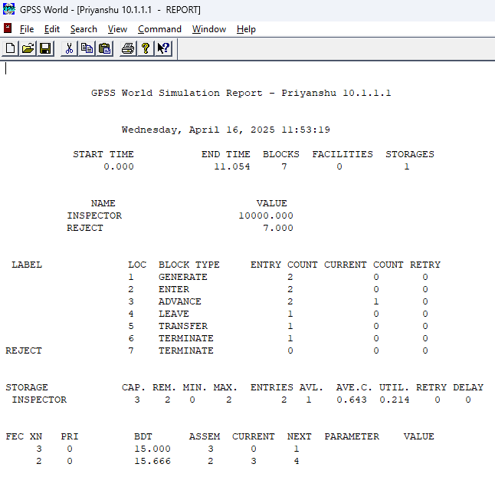
Output:

Q.2. Fuel Station Simulation: One vehicle arrives every 2±2 minutes. It takes 5±2 minutes to fuel one vehicle. Number of nozzles = 2. Fuel station operates 10 hours a day. Write a GPSS program to simulate operation of fuel station for entire day.
Source Code:
GENERATE 2,2
QUEUE FUELQ
ENTER NOZZLE,1
DEPART FUELQ
ADVANCE 5,2
LEAVE NOZZLE,1
TERMINATE 1
NOZZLE STORAGE 2
START 600
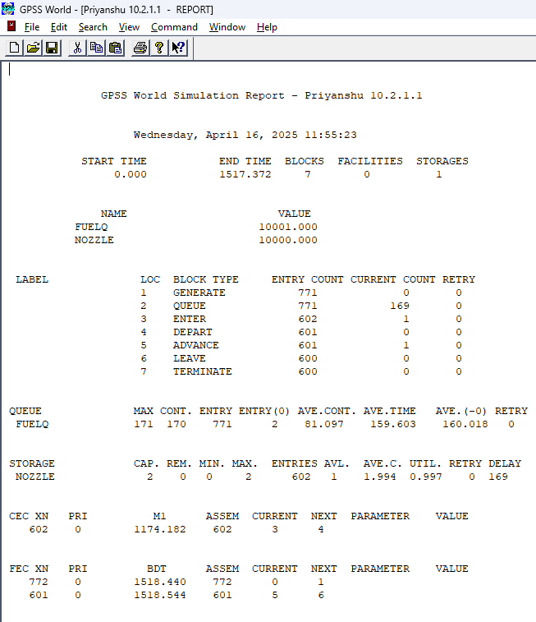
Output:

